
Print Materials Order Form
For free PaintCare brochures and factsheets
california

Please complete this form and send to PaintCare. Indicate the quantities you would like below.

Store Name
Street Address
City/State/Zip
Contact Person
Phone
Email

Program Brochure  General information about the PaintCare Program |  |  | Large Volume Pick-Up Fact Sheet  How to request a pickup for 300 gallons or more
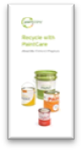 | Quantity |  | 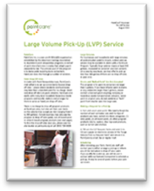 | Quantity
 |  | English |  |  | English
 |  | Spanish |  |  | Spanish
 |  | Chinese
 |  | Korean
 |  | Russian
Mini card  Quick reference to help find a drop-off site |  |  | program poster  General PaintCare information on 1 page 8.5 x 11
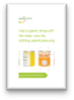 | Quantity |  | 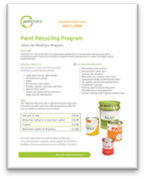 | Quantity
 |  | English |  |  | English
 |  | Spanish |  |  | Spanish
 |  | Russian
trade painter fact sheet  General information for painting contractors |  |  | brochure holder  Keep the program brochures neat and in one place
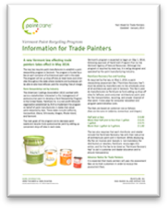 | Quantity
 |  | English | Would you like a brochure holder for the counter? (yes/no) | yes / no
 |  | Spanish | Would you like a brochure holder for the counter? (yes/no)
 |  | Chinese | Would you like a brochure holder for the counter? (yes/no)
 |  | Korean | Would you like a brochure holder for the counter? (yes/no)
 |  | Russian | Would you like a brochure holder for the counter? (yes/no)

send Complete Form to:
Email: retail@paintcare.org  Fax: (855) 385-2020 | Mail: PaintCare, 1500 Rhode Island Ave. NW, Washington DC 20005  Phone: (855) 724-6809)

