Suggestions on How to Link to PaintCare
- LONG VERSION

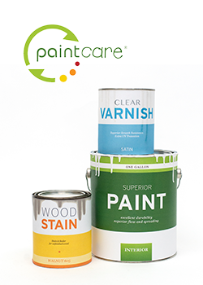 | Do you have only paint, stain and varnish to recycle?  Many paint stores now take back house paint (including stain and varnish) year-round during their regular business hours as part of the PaintCare program. If the only household hazardous wastes you have for recycling or disposal are paint, finding a place to take them is now easier and more convenient in our community. [Note: these sites do not accept non-paint products such as thinner, solvents, spackle, pesticides, or cleaning chemicals.]  The {state name} Paint Stewardship Program is run by PaintCare, a nonprofit organization funded by a nominal fee on the price of new paint. Residents and most businesses from any part of the state may use any PaintCare retail location. PaintCare also offers a pick-up service if you have at least 300 gallons of unwanted paint.  There is no charge when you drop off your paint or have it picked up. To find participating drop-off locations, learn more about the pick-up service, or find out which products are accepted, please visit www.paintcare.org or call (855) 724-6809.
- SHORT VERSION

 | Do you have only paint, stain and varnish to recycle?  Many paint stores now take back paint, stain, and varnish year-round during their regular business hours as part of the PaintCare program. The program is free for all residents and most businesses. To find participating drop-off locations and details about which products are accepted, please visit www.paintcare.org or call (855) 724-6809.
IMAGES FOR DOWNLOAD
http://www.paintcare.org/partnerlink/

