Order Form for PaintCare Print Materials CONNECTICUT
For free PaintCare brochures, fact sheets, posters and other items

Store Name
Street Address
City/State/Zip
Contact Person
Phone
Email

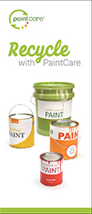 |  | 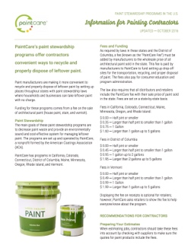 | 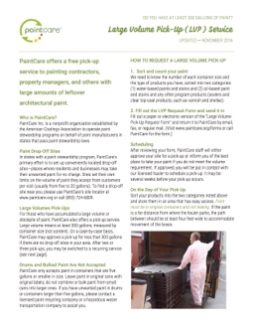 | 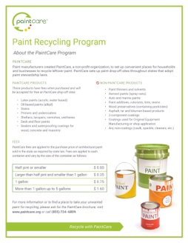
A | B | C | D | E

How Many?
 | Item | Description | English | Polish, Portuguese, Spanish
A | Program Brochure | General information about the PaintCare Program |  | (Spanish only)
B | Mini Card | Quick reference to help customers find drop-off sites |  | (Spanish only)
C | Painting Contractor Fact Sheet | Information about the program especially for painting contractors
D | Large Volume Pick-Up Fact Sheet | How to request a direct pick-up for 200 gallons or more |  | (Spanish only)
E | Program Poster | General PaintCare information on 1 page (8.5 x 11) |  | (Spanish only)
 | Brochure Holder | Would you like a holder to keep the brochures neat and in one place? | ____ yes | ____ no

Three Ways to Order

Online: www.paintcare.org/forms  By Phone: (855) 724-6809 | Fill out this form and send it to us:  Email: retail@paint.org  Fax: (855) 385-2020  Mail: PaintCare, 901 New York Ave NW, Washington DC 20001

